1. **What is meant by Digital Image Processing? Explain how digital images can be represented?**

* Digital image processing can be defined as processing of digital image in a digital manner meaning that using a digital device like computer or others.
* Digital Image Processing is used to manipulate the images by the use of algorithms.
* Digital Image Processing (DIP) is a software which is used to manipulate the digital images by the use of computer system.
* It is also used to enhance the images, to get some important information from it.
* It is also used in the conversion of signals from an image sensor into the digital images.
* A certain number of algorithms are used in image processing.
* DIP focuses on developing a computer system that is able to perform processing on an image.
* The input of that system is a digital image and the system process that image using efficient algorithms, and gives an image as an output.
* The most common example is Adobe Photoshop
* The digital image processing is getting more and more importance nowadays because of its two major application areas:
  + Improvement of pictorial in formation for human interpretation.
  + Processing of image data for storage, transmission, and representation for autonomous machine perception.

**Characteristics of Digital Image Processing**

* It uses software, and some are free of cost.
* It provides clear images.
* Digital Image Processing do image enhancement to recollect the data through images.
* It is used widely everywhere in many fields.
* It reduces the complexity of digital image processing.
* It is used to support a better experience of life.

**Advantages of Digital Image Processing**

* Image reconstruction (CT, MRI, SPECT, PET)
* Image reformatting (Multi-plane, multi-view reconstructions)
* Fast image storage and retrieval
* Fast and high-quality image distribution.
* Controlled viewing (windowing, zooming)

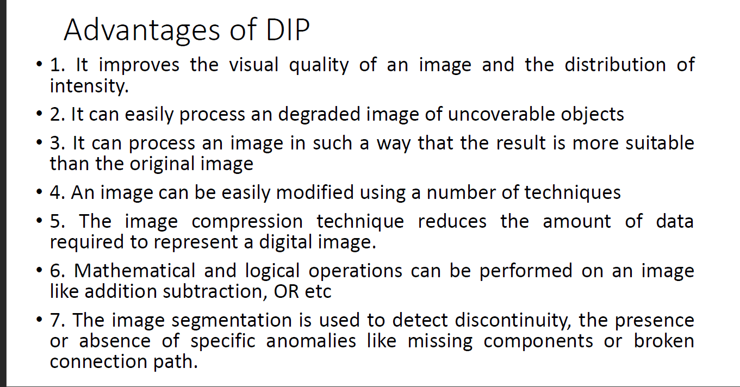

**Disadvantages of Digital Image Processing**

* It is very much time-consuming.
* It is very much costly depending on the particular system.
* Qualified persons can be used.

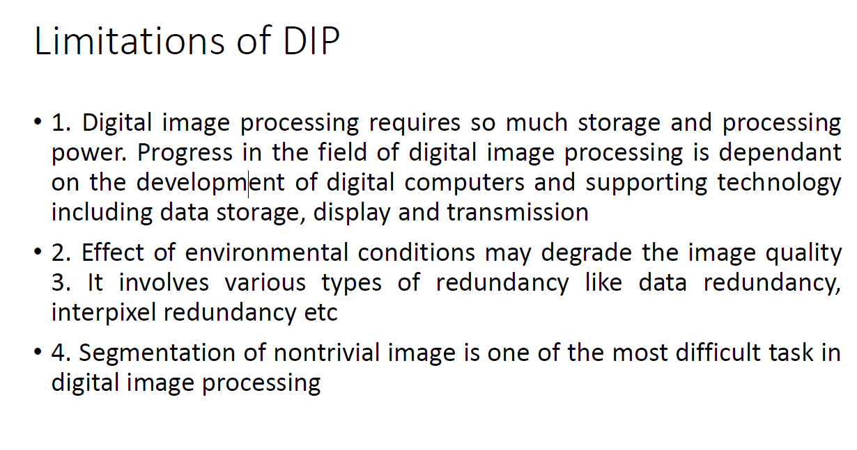

**Explain how digital images can be represented**

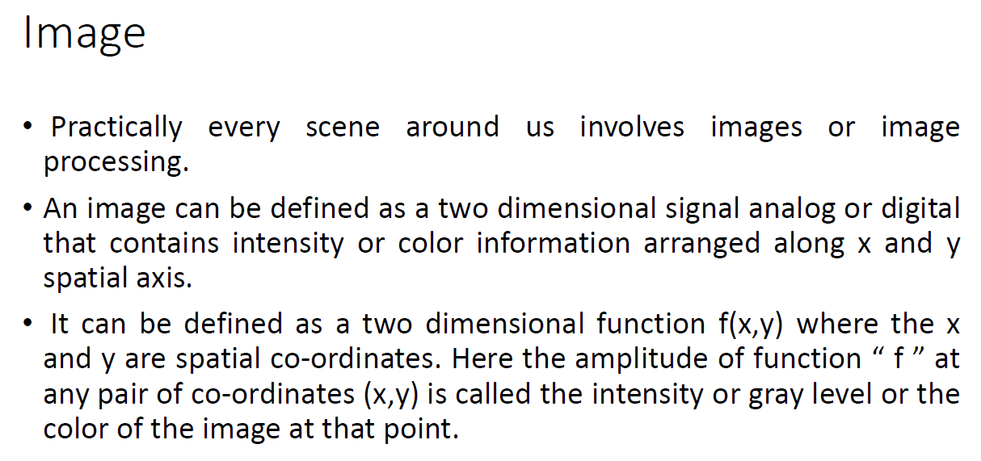

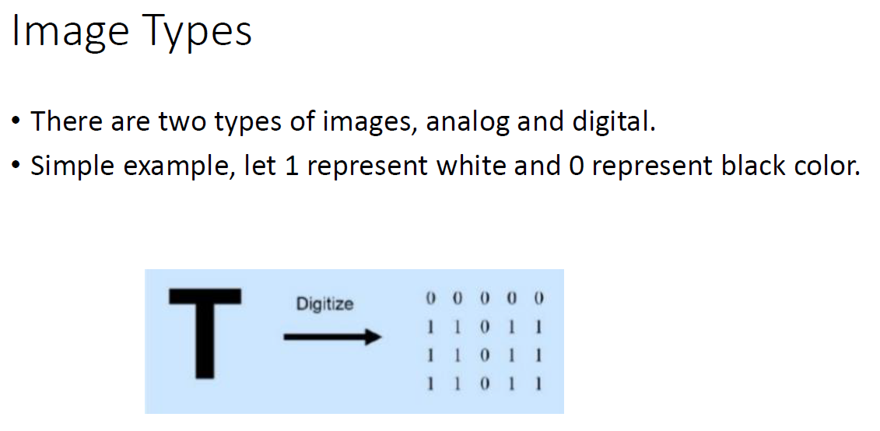

**Analog Image**

* Analog image is a two dimensional function of f(s,t) considered in the continuous time domain.
* An image can be defined as a two dimensional function f(x,y) where the x and y are spatial co-ordinates. Here the amplitude of function “ f ” at any pair of co-ordinates (x,y) is called the intensity or gray level or the color of the image at that point.
* When x, y and the amplitude values of f are continuous quantities then the image is referred as analog image.

**Digital Image**

* An image can be defined as a two dimensional function f(x,y) where the x and y are spatial co-ordinates. Here the amplitude of function “ f ” at any pair of co-ordinates (x,y) is called the intensity or gray level or the color of the image at that point.
* When x, y and the amplitude values of f are all finite and discrete quantities then the image is referred as digital image. Digital image processing refers to the processing of digital images by means of digital computer.
* A digital image is composed of a finite number of elements, each of which has a particular location and value. These elements are referred to as pels, pixels, picture elements or image elements

1. **Discuss the different components of Digital Image Processing with a diagram.**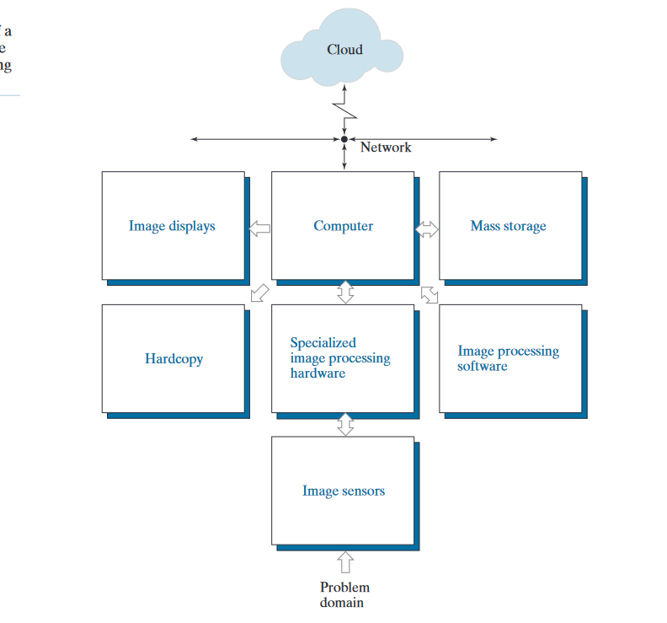

**The computer** in an image processing system is a general-purpose computer and can range from a PC to a supercomputer.

In dedicated applications, sometimes custom computers are used to achieve a required level of performance, but our interest here is on general-purpose image processing systems.

In these systems, almost any well-equipped PC-type machine is suitable for off-line image processing tasks.

**Mass storage** is a must in image processing applications. An image of size 1024 1024× pixels, in which the intensity of each pixel is an 8-bit quantity, requires one megabyte of storage space if the image is not compressed.

When dealing with image databases that contain thousands, or even millions, of images, providing adequate storage in an image processing system can be a challenge.

Digital storage for image processing applications falls into three principal categories:

(1) short-term storage for use during processing;

(2) on-line storage for relatively fast recall

(3) archival storage, characterized by infrequent access.

**Image displays** in use today are mainly color, flat screen monitors. Monitors are driven by the outputs of image and graphics display cards that are an integral part of the computer system.

**Hardcopy devices** for recording images include laser printers, film cameras, heat- sensitive devices, ink-jet units, and digital units, such as optical and CD-ROM disks. Film provides the highest possible resolution, but paper is the obvious medium of choice for written material.

**Software:**

for image processing consists of specialized modules that perform specific tasks

**Image Sensor:**

With reference to sensing, two elements are required to acquire digital images: a sensor and a digitizer.

**Specialized image processing hardware:**

usually consists of the digitizer just mentioned, plus hardware that performs other primitive operations, such as an arithmetic logic unit (ALU).

1. **Illustrate the fundamental steps in Digital Image Processing with a diagram.**

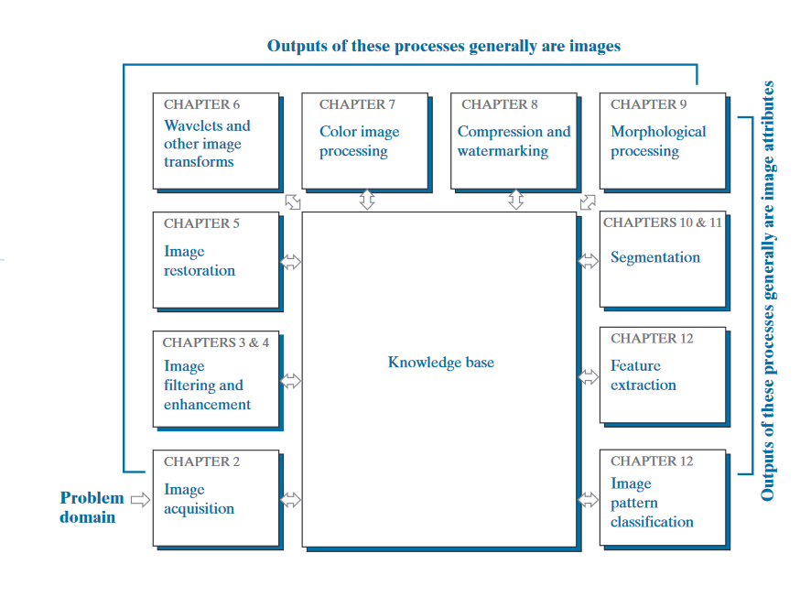

**Image acquisition**.

Acquisition could be as simple as being given an image that is already in digital form. Generally, the image acquisition stage involves pre-processing, such as scaling.

**Image enhancement**

is the process of manipulating an image so the result is more suitable than the original for a specific application.

The word specific is important here, because it establishes at the outset that enhancement techniques are problem oriented.

Thus, for example, a method that is quite useful for enhancing X-ray images may not be the best approach for enhancing satellite images taken in the infrared band of the electromagnetic spectrum.

**Image restoration**

It is an area that also deals with improving the appearance of an image.

unlike enhancement, which is subjective, image restoration is objective, in the sense that restoration techniques tend to be based on mathematical or probabilistic models of image degradation.

Enhancement, on the other hand, is based on human subjective preferences regarding what constitutes a “good” enhancement result.

**Wavelets and other Image Transformation:**

are the foundation for representing images in various degrees of resolution

other transforms that are used routinely in image processing.

**color image processing**

is an area that has been gaining in importance because of the significant increase in the use of digital images over the internet. Color is used also as the basis for extracting features of interest  
in an image.

**Compression,**

as the name implies, deals with techniques for reducing the storage required to save an image, or the bandwidth required to transmit it.

Although storage technology has improved significantly over the past decade, the same cannot be  
said for transmission capacity.

This is true particularly in uses of the internet, which are characterized by significant pictorial content. Image compression is familiar to most users of computers in the form of image file extensions, such as the jpg file extension used in the JPEG image compression standard.

**Morphological processing**

deals with tools for extracting image components that are useful in the representation and description of shape

**Segmentation partitions** an image into its constituent parts or objects. In general, autonomous segmentation is one of the most difficult tasks in digital image   
. A rugged segmentation procedure brings the process a long way toward successful solution of imaging problems

**Feature extraction**

It is almost always following the output of a segmentation stage, which usually is raw pixel data, constituting either the boundary of a region or all the points in the region itself.

Feature extraction consists of feature detection and feature description.

Feature detection refers to finding the features in an image, region, or boundary.

**Image pattern classification** is the process that assigns a label to an  
object based on its feature descriptors. In the last chapter of the book, we will discuss  
methods of image pattern classification ranging from “classical” approaches such as  
minimum-distance, correlation, and Bayes classifiers, to more modern approaches  
implemented using deep neural networks.

**6.Explain about image sampling and quantization process.**

**Image Sampling and Quantization:**

The output of most sensors is a continuous voltage waveform whose amplitude and spatial behaviour are related to the physical phenomenon being sensed.

To create a digital image, we need to convert the continuous sensed data into digital form.  
This process includes 2 processes:

1. **Sampling:** Digitizing the co-ordinate value is called sampling.
2. **Quantization:** Digitizing the amplitude value is called quantization.

**Conversion of analog signal to digital signal:**

The output of most of the image sensors is an analog signal, and we cannot apply digital processing on it because we cannot store it. We cannot store it because it requires infinite memory to store a signal that can have infinite values.

So we have to convert an analog signal into a digital signal.

To create an image which is digital, we need to covert continuous data into digital form. There are two steps in which it is done.

* **Sampling**
* **Quantization**

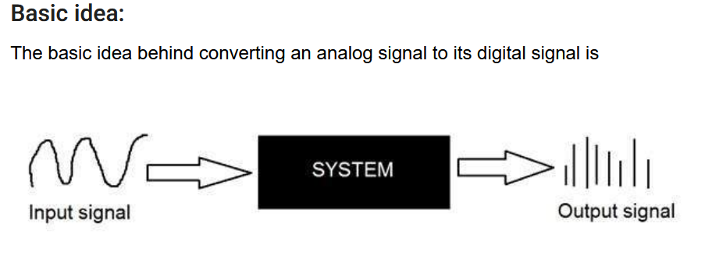

**Sampling.**

Sampling has already been introduced in our tutorial of introduction to signals and system. But we are going to discuss here more.

Here what we have discussed of the sampling.

The term sampling refers to take samples

We digitize x axis in sampling

It is done on independent variable

In case of equation y = sin(x), it is done on x variable

It is further divided into two parts , up sampling and down sampling

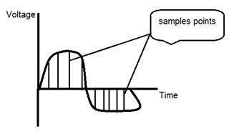

If you will look at the above figure, you will see that there are some random variations in the signal. These variations are due to noise. In sampling we reduce this noise by taking samples. It is obvious that more samples we take, the quality of the image would be better, the noise would be more removed and same happens vice versa.

However, if you take sampling on the x axis, the signal is not converted to digital format, unless you take sampling of the y-axis too which is known as quantization. The more samples eventually means you are collecting more data, and in case of image, it means more pixels.

* Sampling has a relationship with image pixels.
* The total number of **pixels in an image** can be calculated **as Pixels = total no of rows * total no of columns**.
* For example, let’s say we have total of 36 pixels, that means we have a square image of 6X 6.
* As we know in sampling, that more samples eventually result in more pixels.
* So it means that of our continuous signal, we have taken 36 samples on x axis.
* That refers to 36 pixels of this image.
* Also the number sample is directly equal to the number of sensors on CCD array.

## Oversampling.

* In the beginning we have define that sampling is further categorize into two types. Which is up sampling and down sampling. Up sampling is also called as over sampling.
* The oversampling has a very deep application in image processing which is known as Zooming.

## Zooming :

* Zooming refers to increase the quantity of pixels, so that when you zoom an image, you will see more detail.
* The increase in the quantity of pixels is done through oversampling.
* The one way to zoom is, or to increase samples, is to zoom optically, through the motor movement of the lens and then capture the image.
* But we have to do it, once the image has been captured.

## What is quantization

Quantization is opposite to sampling. It is done on y axis. When you are quantizing an image, you are actually dividing a signal into quanta(partitions).

On the x axis of the signal, are the co-ordinate values, and on the y axis, we have amplitudes. So digitizing the amplitudes is known as Quantization.

Here how it is done

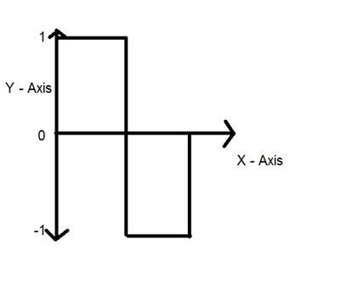

You can see in this image, that the signal has been quantified into three different levels. That means that when we sample an image, we actually gather a lot of values, and in quantization, we set levels to these values. This can be more clear in the image below.

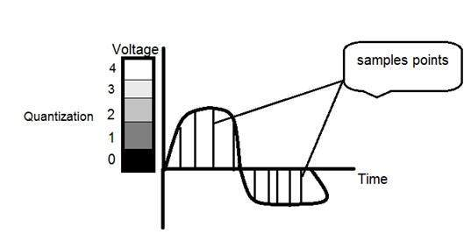

In the figure shown in sampling, although the samples has been taken, but they were still spanning vertically to a continuous range of gray level values. In the figure shown above, these vertically ranging values have been quantized into 5 different levels or partitions. Ranging from 0 black to 4 white. This level could vary according to the type of image you want.

The relation of quantization with gray levels has been further discussed below.

Relation of Quantization with gray level resolution:

The quantized figure shown above has 5 different levels of gray. It means that the image formed from this signal, would only have 5 different colors. It would be a black and white image more or less with some colors of gray. Now if you were to make the quality of the image more better, there is one thing you can do here. Which is, to increase the levels, or gray level resolution up. If you increase this level to 256, it means you have an gray scale image. Which is far better then simple black and white image.

Now 256, or 5 or what ever level you choose is called gray level. Remember the formula that we discussed in the previous tutorial of gray level resolution which is,

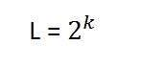

We have discussed that gray level can be defined in two ways. Which were these two.

* Gray level = number of bits per pixel (BPP).(k in the equation)
* Gray level = number of levels per pixel.

In this case we have gray level is equal to 256. If we have to calculate the number of bits, we would simply put the values in the equation. In case of 256levels, we have 256 different shades of gray and 8 bits per pixel, hence the image would be a gray scale image.

## Reducing the gray level

Now we will reduce the gray levels of the image to see the effect on the image.

### For example

Lets say you have an image of 8bpp, that has 256 different levels. It is a grayscale image and the image looks something like this.

### 256 Gray Levels

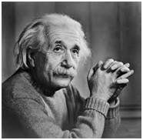

Now we will start reducing the gray levels. We will first reduce the gray levels from 256 to 128.

### 128 Gray Levels

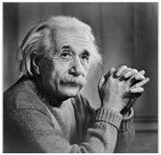

There is not much effect on an image after decrease the gray levels to its half. Lets decrease some more.

### 64 Gray Levels

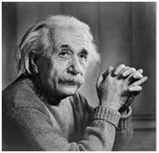

Still not much effect, then lets reduce the levels more.

### 32 Gray Levels

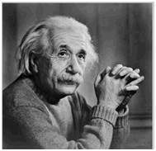

Surprised to see, that there is still some little effect. May be its due to reason, that it is the picture of Einstein, but lets reduce the levels more.

### 16 Gray Levels

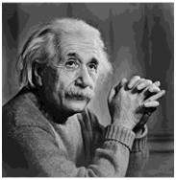

Boom here, we go, the image finally reveals, that it is effected by the levels.

### 8 Gray Levels

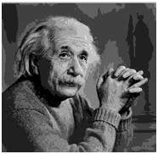

### 4 Gray Levels

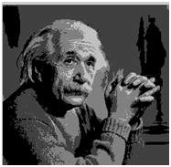

Now before reducing it, further two 2 levels, you can easily see that the image has been distorted badly by reducing the gray levels. Now we will reduce it to 2 levels, which is nothing but a simple black and white level. It means the image would be simple black and white image.

### 2 Gray Levels

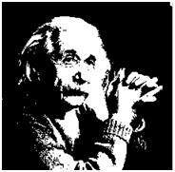

That’s the last level we can achieve, because if reduce it further, it would be simply a black image, which can not be interpreted.

## Contouring

There is an interesting observation here, that as we reduce the number of gray levels, there is a special type of effect start appearing in the image, which can be seen clear in 16 gray level picture. This effect is known as Contouring.

7. **Write a short note on Image interpolation.**

* Image interpolation **occurs** when you **resize or distort your image** from one **pixel grid to another**.
* Image resizing is necessary when you need to increase or decrease the total number of pixels, whereas remapping can occur when you are correcting for lens distortion or rotating an image.

Zooming refers to increase the quantity of pixels, so that when you zoom an image, you will see more detail.

Interpolation works by using known data to estimate values at unknown points. Image interpolation works in two directions, and tries to achieve a best approximation of a pixel's intensity based on the values at surrounding pixels. Common interpolation algorithms can be grouped into **two categories: adaptive and non-adaptive**. Adaptive methods change depending on what they are interpolating, whereas non-adaptive methods treat all pixels equally.

Non-adaptive algorithms include: nearest neighbor, bilinear, bicubic, spline, sinc, lanczos and others.

Adaptive algorithms include many proprietary algorithms in licensed software such as: Qimage, PhotoZoom Pro and Genuine Fractals.

Many compact digital cameras can perform both an optical and a digital zoom. A camera performs an optical zoom by moving the zoom lens so that it increases the magnification of light. However, a digital zoom degrades quality by simply interpolating the image. Even though the photo with digital zoom contains the same number of pixels, the detail is clearly far less than with optical zoom.

In this lecture zooming and shrinking will be introduced and for this purpose interpolation is introduced and discussed. Many various interpolation techniques will be briefly introduced and three of them namely, nearest neighbour, bilinear, and bicubic interpolations will be discussed in more details with visual examples. Also required MATLAB comments for generating the shown examples will be provided.

9**. Choose some examples of fields that use Digital Image Processing.**

Digital Image processing is not just limited to adjust the spatial resolution of the everyday images captured by the camera. It is not just limited to increase the brightness of the photo, e.t.c. Rather it is far more than that.

Electromagnetic waves can be thought of as stream of particles, where each particle is moving with the speed of light. Each particle contains a bundle of energy. This bundle of energy is called a photon.

**Fields that Use Digital Image Processing**

Unlike humans, who are limited to the visual band of the electromagnetic (EM) spectrum, imaging machines cover almost the entire EM spectrum, ranging from gamma to radio waves. They can operate on images generated by sources that humans are not accustomed to associating with images.

* Gamma ray imaging
* X-ray imaging
* Imaging in an ultraviolet band
* Imaging in the visible and infrared bands
* Imaging in the microwave band
* Imaging in the radio band

**Gamma ray imaging:**

imaging based on gamma rays include nuclear medicine and astronomical observations.

**PET :**

Another major modality of nuclear imaging is positron emission tomography.

**X-ray imaging :**

X-rays are the oldest sources of EM radiation used for imaging. In digital radiography, digital images are obtained by one of the two methods:

1. By digitizing x-ray films

2. By having the x-rays that pass through the patient and fall onto a device such as phosphor screen that convert x- rays into light

**WHAT IS MEAN BY X RAY?**

X-rays are a type of radiation called electromagnetic waves.

X-ray imaging creates pictures of the inside of your body.

The images show the parts of your body in different shades of black and white.

This is because different tissues absorb different amounts of radiation

**Imaging in the ultraviolet band:**

Applications of ultraviolet “light” are varied..

the major application of imaging in ultraviolet band includes lithography, industrial inspection, microscopy, lasers, biological imaging and astronomical observations.

We illustrate imaging in this band with examples from microscopy and astronomy.

ultraviolet light is used in fluorescence microscopy, one of the fastest growing areas of microscopy.

Fluorescence is a phenomenon discovered in the middle of the nineteenth century, when it was first observed that the mineral fluorspar fluoresces when ultraviolet light is directed upon it.

**What mean by the UV Band:**

True ultraviolet (UV) imaging inspection isn’t used often in machine vision.

However, as UV-sensitive cameras and UV-emitting light sources, particularly LED lighting, have become widely available and less costly, new applications are emerging.

Monochromatic UV sources, such as lasers and LEDs, are desirable in machine vision applications because when paired with appropriate Bandpass Filters, camera optics don’t need to be achromatic, significantly lowering cost.

**Imaging in the visible and infrared bands:**

The infrared band is used in conjunction with visual imaging. Another major area of visual processing is remote sensing

Considering that the visual band of the electromagnetic spectrum is the most familiar in all our activities, it is not surprising that imaging in this band outweighs by far all the others in terms of breadth of application.

The infrared band often is used in conjunction with visual imaging, so we have grouped the visible and infrared bands in this section for the purpose of illustration.

We consider in the following discussion applications in light microscopy, astronomy, remote sensing, industry, and law enforcement.

Imaging systems may be provided with image sensors for capturing information about incident light intensities in the visible and infrared bands of light. The means of capturing information about visible light may be unintentionally and undesirably influenced by infrared light.

**Imaging in the microwave band:**

The major application of imaging in the microwave band is radar.

M**crowave imaging** is a science which has been evolved from older detecting/locating techniques in order to evaluate hidden or embedded objects in a structure using [electromagnetic](https://en.wikipedia.org/wiki/Electromagnetic) (EM) waves in [microwave](https://en.wikipedia.org/wiki/Microwave) regime.

**Imaging in the radio band:**

the major application of imaging in the radio band include medicine and astronomy.

Refer Javatpoint : <https://www.javatpoint.com/computer-fundamentals-tutorial>

## Image sharpening and restoration

It refers to the process in which we can modify the look and feel of an image. It basically manipulates the images and achieves the desired output. It includes conversion, sharpening, blurring, detecting edges, retrieval, and recognition of images.

## Robot vision

There are several robotic machines which work on the digital image processing. Through image processing technique robot finds their ways, for example, hurdle detection root and line follower robot.

## 4) Pattern recognition

It involves the study of image processing, it is also combined with artificial intelligence such that computer-aided diagnosis, handwriting recognition and images recognition can be easily implemented. Now a days, image processing is used for pattern recognition.

## 5) Video processing

It is also one of the applications of digital image processing. A collection of frames or pictures are arranged in such a way that it makes the fast movement of pictures. It involves frame rate conversion, motion detection, reduction of noise and colour space conversion etc.

**8. Discuss some of the basic relationships between pixels in a digital image.**

**Neighbors of a Pixel :**

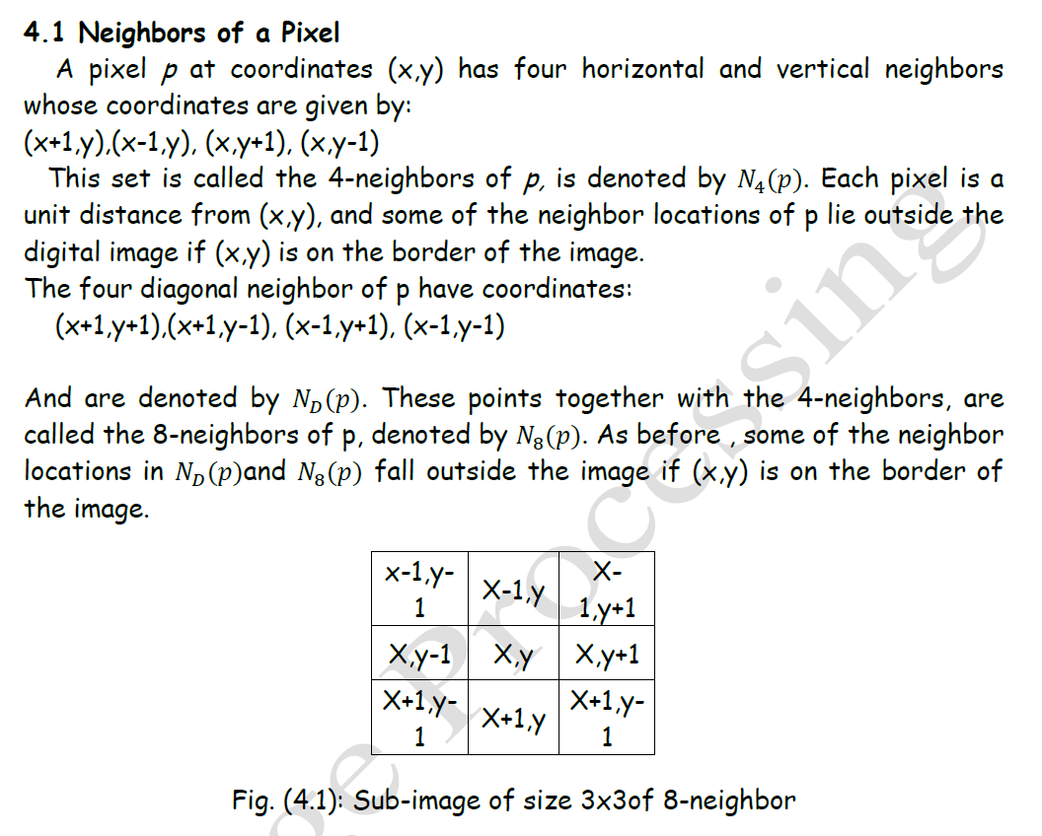

# **Adjacency between pixels**

Let **V** be the set of intensity values used to define adjacency.

In a binary image, V ={1} if we are referring to adjacency of pixels with value 1. In a gray-scale image, the idea is the same, but set V typically contains more elements.

For example, in the adjacency of pixels with a range of possible intensity values 0 to 255, set V could be any subset of these 256 values.

We consider three types of adjacency:

**a) 4-adjacency:** Two pixels p and q with values from V are 4-adjacent if q is in the set N4(p).

**b) 8-adjacency:** Two pixels p and q with values from V are 8-adjacent if q is in the set N8(p).

**c) m-adjacency(mixed adjacency):** Two pixels p and q with values from V are m-adjacent if

1. q is in N4(p), or
2. 2) q is in ND(p) and the set N4(p)∩N4(q) has no pixels whose values are from V.

# **Connectivity between pixels**

It is an important concept in digital image processing.

It is used for establishing boundaries of objects and components of regions in an image.

Two pixels are said to be connected:

* if they are adjacent in some sense(neighbour pixels,4/8/m-adjacency)
* if their Gray levels satisfy a specified criterion of similarity(equal intensity level)

There are three types of connectivity on the basis of adjacency. They are:

**a) 4-connectivity:** Two or more pixels are said to be 4-connected if they are 4-adjacent with each others.

**b) 8-connectivity:** Two or more pixels are said to be 8-connected if they are 8-adjacent with each others.

**c) m-connectivity:** Two or more pixels are said to be m-connected if they are m-adjacent with each others.

